Day 7:
- Simple Test Case:

class Calculator{
int add(int a, int b){
return a+b;
}
int subtract(int a,int b){
return a>b?a-b:b-a;
}
}

package org.example;
import org.junit.Test;
import java.awt.*;
import static org.junit.jupiter.api.Assertions.assertEquals;
public class Calc_demo {
@Test
public void test_add(){
Calculator cal = new Calculator();
int ans = cal.add(10,20);
assertEquals(30, ans);
}
@Test
public void test_subtract(){
Calculator cal =new Calculator();
int ans = cal.subtract(30,20);
assertEquals(20,ans,"Expected 10 but got another");
}
}

2)Bank Account:
package org.example;
import org.junit.Test;
import static org.junit.jupiter.api.Assertions.assertEquals;
import static org.junit.jupiter.api.Assertions.assertThrows;
public class Bank_test {
@Test
public void Withdraw(){
Bank bank = new Bank("1",2000);
Exception ex = assertThrows(IllegalArgumentException.class, () -> {
bank.withdraw(2000.0);
});
assertEquals("Insufficient", ex.getMessage(),"UnMatched Message");
}
}

Java Code:
package org.example;
import java.util.concurrent.ExecutionException;
public class Bank{
private String accountNumber;
private double balance;
public Bank(String accountNumber, double balance) {
this.accountNumber = accountNumber;
this.balance = balance;
}
public String getAccountNumber() {
return accountNumber;
}
public double getBalance() {
return balance;
}
public void deposit(double amount) {
if (amount <= 0) {
throw new IllegalArgumentException("Deposit must be positive");
}
balance += amount;
}
public void withdraw(double amount) {
if (amount >= balance) {
throw new IllegalArgumentException("Insufficient balance");
}
balance -= amount;
}
}

3)Fail Test Cases:
- public void checkAccountNumber(){
Bank bank = new Bank("2",200);
assertEquals("1",bank.getAccountNumber(),"Not Expected Account Number");
}
@Test
public void deposit(){
Bank bank = new Bank("1",200);
Exception ex = assertThrows(IllegalArgumentException.class,()->{
bank.deposit(-1);
});
assertEquals("Deposit must be positive",ex.getMessage());
}

4)Paramterized Junit Code:
Java code:
public class Palindrome {
public boolean check(String str){
char [] c= str.toCharArray();
for(int i = 0;i<c.length/2;i++){
if(c[i] != c[c.length-i-1]){
return false;
}
}
return true;
}
}

Junit Code:
package org.example;
import org.junit.Test;
import org.junit.jupiter.params.ParameterizedTest;
import org.junit.jupiter.params.provider.ValueSource;
import static org.junit.jupiter.api.Assertions.assertTrue;
public class Palindrome_test {
@ParameterizedTest
@ValueSource(strings = {"amma", "mom", "nitin"})
void test_Palindrome(String Candidate){
Palindrome p = new Palindrome();
assertTrue(p.check(Candidate));
}
@Test
public void test_failcase(){
Palindrome p1 = new Palindrome();
assertTrue(p1.check("hello"),"Not a palindrome");
}
}

5) Junit Test Life Cycle Hooks:
- Test lifecycle that is managed through four primary annotations that are @BeforeAll, @BeforeEach, @AfterEach, and @AfterAll.
- @BeforeAll – It is a class level clean up. i.e if we need to perform somethings before all perform all the test cases.
- @BeforeEach – Used Before every test methods got executed.
- @Test – Actual Test cases executed- Test Method.
- @AfterEach - It is carried out after each test approach.(Clean up)
- @AfterAll – Class Level clean up Annotation.
6)Junit Hook Life Cycle :
package org.example;
import org.junit.Test;
import org.junit.jupiter.api.AfterEach;
import org.junit.jupiter.api.BeforeEach;
import static org.junit.jupiter.api.Assertions.assertEquals;
public class Hook_test {
private DatabaseService db;
@BeforeEach
void init() {
db = new DatabaseService();
db.connect();
}
@AfterEach
void cleanup() {
db.disconnect();
}
@Test
public void testInsertAndFetchPass() {
db.insert("user1", "Bharath");
assertEquals("Bharath", db.fetch("user1"));
}
//fails
@Test
public void testInsertAndFetchFailValue() {
db.insert("user1", "Bharath");
assertEquals("WrongName", db.fetch("user1"), "Expected WrongName but got " + db.fetch("user1"));
}
//fails
@Test
public void testFetchNonExistentKeyFail() {
// No insert performed, so fetch returns null
assertEquals("SomeValue", db.fetch("missingKey"), "Expected SomeValue but got null");
}
}

Database Service:
package org.example;
import java.util.HashMap;
import java.util.Map;
public class DatabaseService {
private Map<String, String> store = new HashMap<>();
public void connect() {
System.out.println("Connected to DB");
}
public void disconnect() {
System.out.println("Disconnected from DB");
}
public void insert(String key, String value) {
store.put(key, value);
}
public String fetch(String key) {
return store.get(key);
}
}

7) In JUnit 5 assertions are used to verify expected results in unit tests.

10) Types of Junit5 Tests:
- Standard Unit Test
- Paramterized Unit Test
- Dynamic Test
- Functional Test
- Nested Test
- Conditional Test
- Life Cycle based Test
11) JVM Architecture:
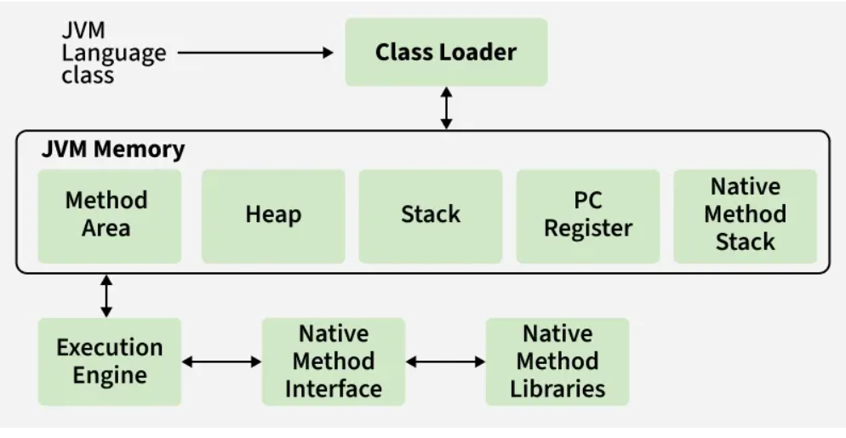

- Java source (.java) -> compiled by javac -> bytecode (.class)
- JVM loads the bytecode, verifies it, links it, and then executes it
- Execution may involve interpreting bytecode or using Just-In-Time (JIT) compilation to convert “hot” code into native machine code for performance
- Garbage collection runs in the background to reclaim memory from unused objects
12) Enums are used to represent a fixed set of predefined constants. They provide type safety, improve readability, prevent invalid values, eliminate magic strings/numbers, work well with switch statements, and can encapsulate data and behavior like regular classes.

13)Enums in Banking Applications:
enum AccountType {
SAVINGS,
CURRENT,
FIXED_DEPOSIT
}

class BankAccount {
AccountType accountType;
}

public class Main {
public static void main(String[] args) {

BankAccount acc = new BankAccount();

acc.accountType = AccountType.SAVINGS;

System.out.println("Account Type : " + acc.accountType);
}
}

14)String Handling Methods:

package org.example;

public class String_Methods {

public static void main(String[] args) {

String customerName = " Bharath Kumar ";
String accountType = "SAVINGS";
String email = "bharath@gmail.com";
String branch = "Bangalore";

// 1. length()
System.out.println("Length = " + customerName.length());

// 2. trim()
System.out.println("Trim = " + customerName.trim());

// 3. toUpperCase()
System.out.println("Upper = " + branch.toUpperCase());

// 4. toLowerCase()
System.out.println("Lower = " + accountType.toLowerCase());

// 5. charAt()
System.out.println("First Letter = " + branch.charAt(0));

// 6. concat()
System.out.println("Concat = " + branch.concat(" Branch"));

// 7. equals()
System.out.println("Equals = " +
accountType.equals("SAVINGS"));

// 8. equalsIgnoreCase()
System.out.println("EqualsIgnoreCase = " +
accountType.equalsIgnoreCase("savings"));

// 9. contains()
System.out.println("Contains = " +
email.contains("@"));

// 10. startsWith()
System.out.println("Starts With = " +
accountType.startsWith("SA"));

// 11. endsWith()
System.out.println("Ends With = " +
email.endsWith(".com"));

// 12. indexOf()
System.out.println("Index Of = " +
email.indexOf("@"));

// 13. lastIndexOf()
System.out.println("Last Index = " +
email.lastIndexOf("a"));

// 14. substring()
System.out.println("Substring = " +
accountType.substring(0, 4));

// 15. replace()
System.out.println("Replace = " +
branch.replace("Bangalore", "Mumbai"));

// 16. replaceAll()
System.out.println("Replace All = " +
email.replaceAll("gmail", "outlook"));

// 17. split()
String data = "12345,SAVINGS,50000";
String[] details = data.split(",");

System.out.println("Account No = " + details[0]);
System.out.println("Type = " + details[1]);
System.out.println("Balance = " + details[2]);

// 18. isEmpty()
String remarks = "";
System.out.println("isEmpty = " +
remarks.isEmpty());

// 19. valueOf()
double balance = 50000.75;
String bal = String.valueOf(balance);
System.out.println("Balance String = " + bal);

// 20. compareTo()
System.out.println("CompareTo = " +
"CURRENT".compareTo("SAVINGS"));

// 21. compareToIgnoreCase()
System.out.println("Compare Ignore Case = " +
"savings".compareToIgnoreCase("SAVINGS"));

// 22. matches()
System.out.println("Matches = " +
email.matches(".*@gmail\\.com"));

// 23. join()
String transaction =
String.join("-",
"TXN1001",
"SUCCESS",
"5000");

System.out.println("Join = " + transaction);

// 24. intern()
String s1 = new String("BANK");
String s2 = s1.intern();

System.out.println("Intern = " + s2);

// 25. toCharArray()
char[] chars = accountType.toCharArray();

System.out.print("Char Array = ");
for(char c : chars){
System.out.print(c + " ");
}

System.out.println();

// 26. repeat()
System.out.println("*".repeat(20));

// 27. format()
String msg = String.format(
"Customer: %s, Balance: %.2f",
"Bharath",
50000.75);

System.out.println(msg);

}

}

